|  |  |  |  |  |  |
| --- | --- | --- | --- | --- | --- |
| Date | 8-Dec-22 | | | Tester Name | Richard Belanger |
| Environment | Penfax - Test | | | Login used | TEST2 |
| Operating System | Windows | Version: | Update: | | |
| Software Used | Edge | Version: | Update: | | |
| Not Applicable | Version: | Update: | | |
| Release version | 22.4.1 | | | | |
| Title | M45.06 Verify Amounts in Each box of RL2 & 45.07 If receiving RL2 also receive T4A | | | | |
| Test Type | Regression | | | | |
| Test Scenario | Run RL2/T4A tax slips | | | | |
|  |  | | | | |
| Expected Results | Amounts will match Member’s calculations | | | | |
| Pass/Fail | Pass | | | JIRA# | N/A |

Describe your steps with screenshots:

SID = 91151

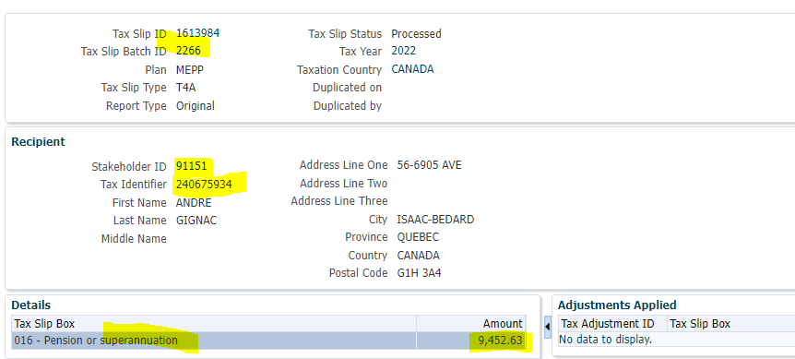

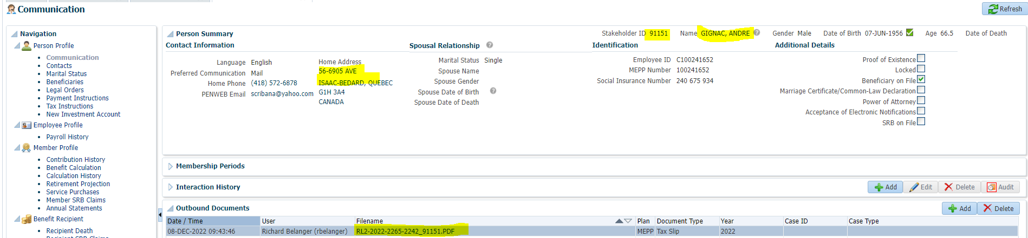

Open Member’s stored RL2 from Communication

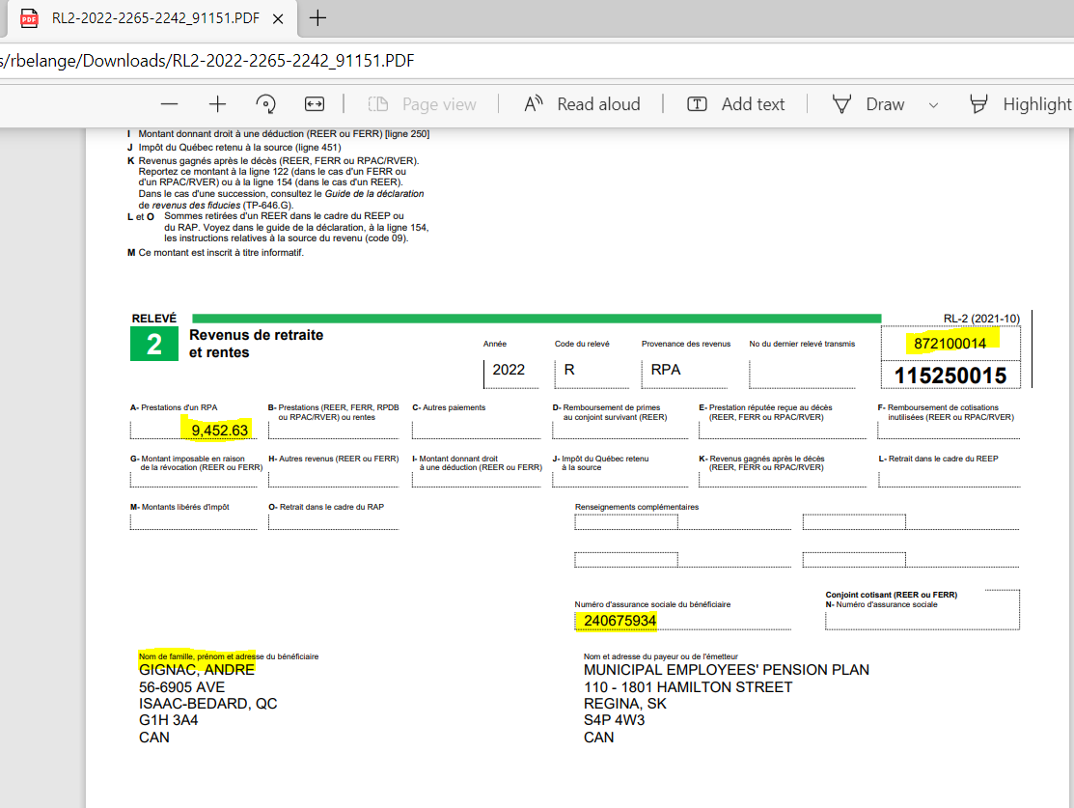

T4A Tax slip

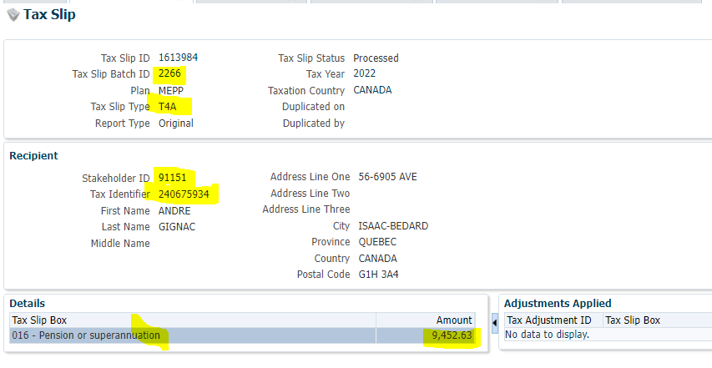

Open Member’s stored T4A from Communication

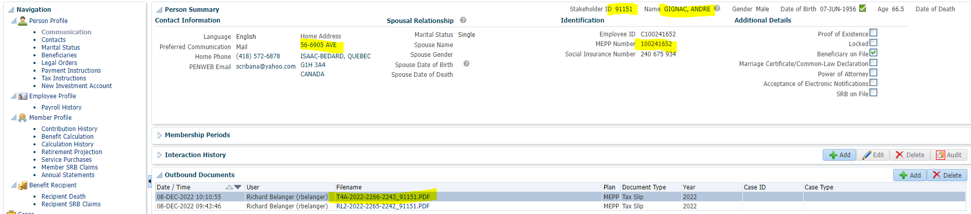

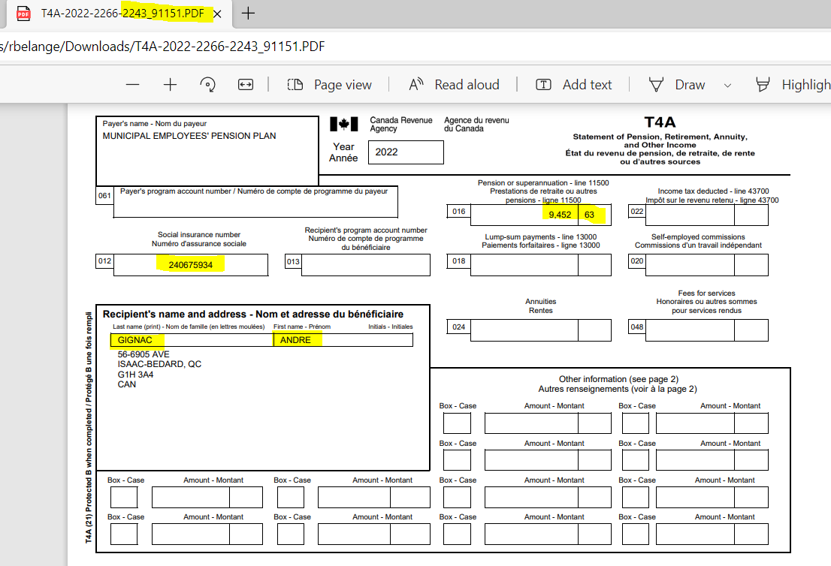

Another Member SID = 117568

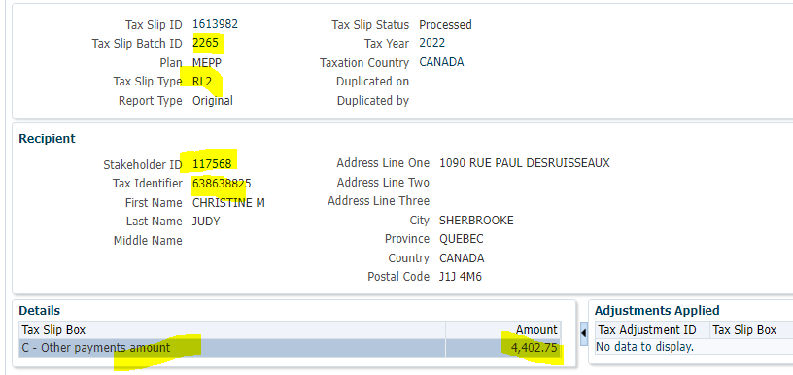

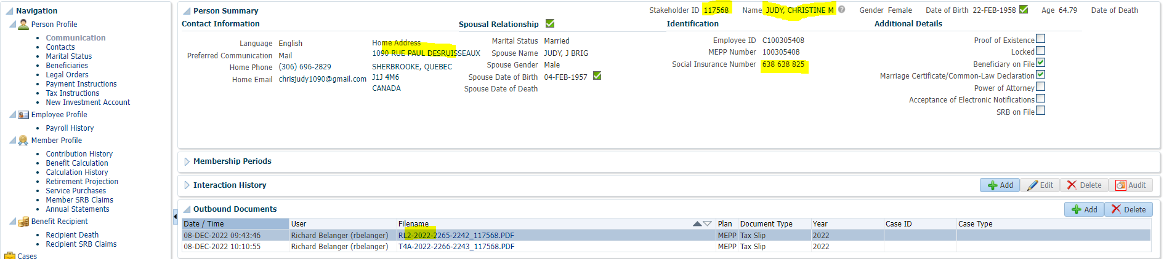

Open Member’s stored RL2 from Communication

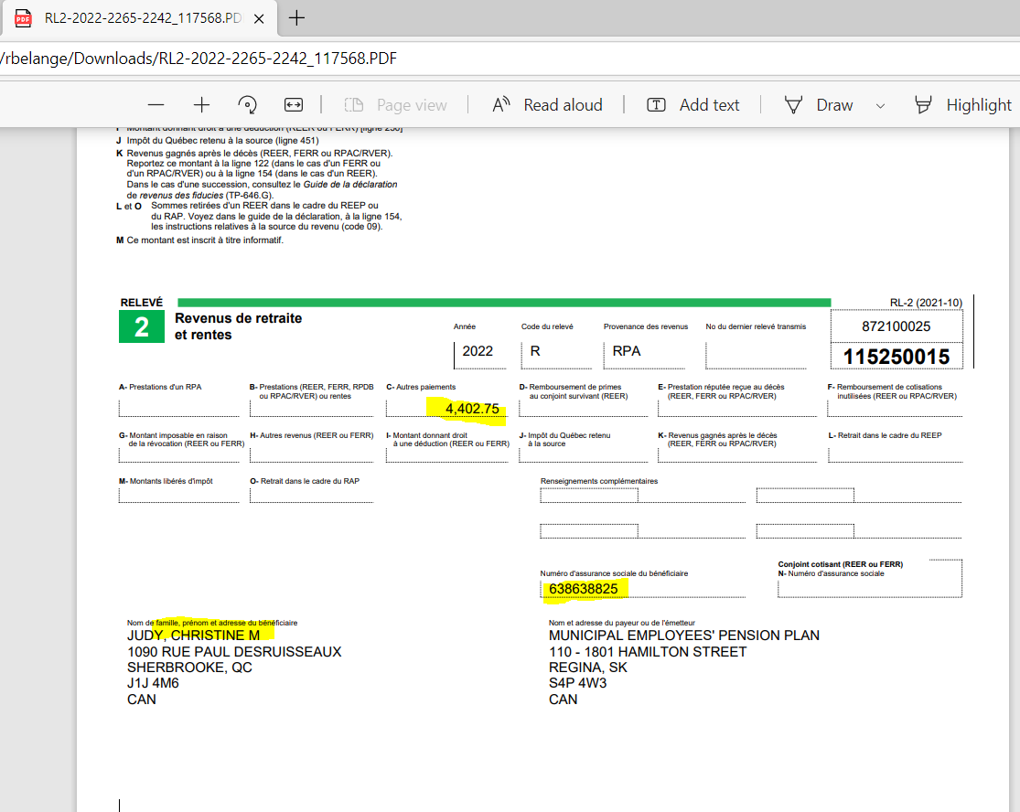

T4A Tax slip

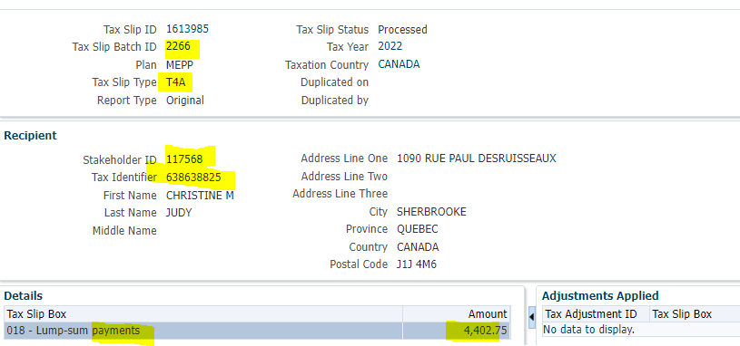

Open Member’s stored T4A from Communication

